Paint Report

By

Mohamed el-maghraby Mohamed 55

Mohamed Kamal Abd el Rahman 59

# Use case digram:

# C:\Users\Magho\AppData\Local\Microsoft\Windows\INetCache\Content.Word\use case.jpg

# UML Class digram:

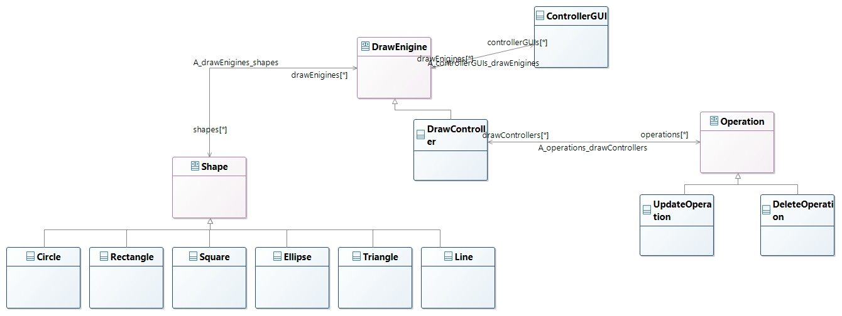

# Sequence Digram:

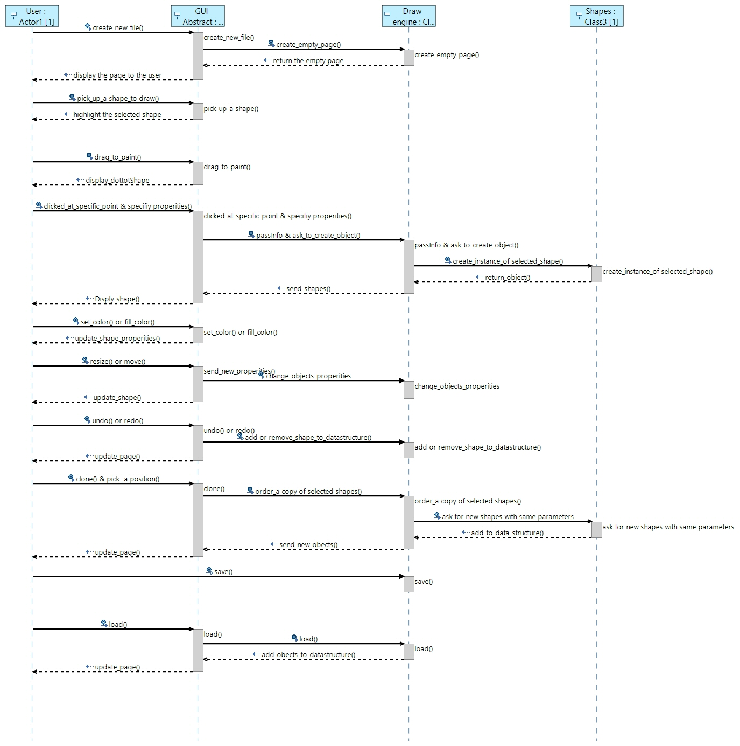

## Describe the DESIGN:

We design the project using MVC model, dividing it to “draw engine” as a controller, “shapes” as models and “GUI” as view.

The design pattern used in the implementation is a “factory” to produce the shapes of different types, “command design pattern” to handle the undo and redo operations and “singleton design pattern” to enforce the user to use one “draw engine”

Save and load is done in JSON and XML, both parsers written by hand from scratch.

Done as bonus:

* Select shapes.
* Draw tangent line to a circle.
* Draw tangent circle to another circle.

## snap shots:

## User guide:

A simple GUI to use, just as paint in windows:

* To draw a shape select it from the top tool bar to be drawn.
* Click at any point in the canvas to draw the selected shape.
* Drag to determine the parameters of the shape.
* If want to select color just choose one from the tool bar and click on the shape to be filled with.
* Save and load are applied with icons with its name.
* Undo and redo enable you to manage the picture well.